FLX Teens Are Alright: Communications Toolkit
Contents:
- Sample Newsletter Images & Write Up
- Sample Social Media Images, Captions & Hashtags
- FLX Teens Are Alright 1-pager

Sample Newsletter Images
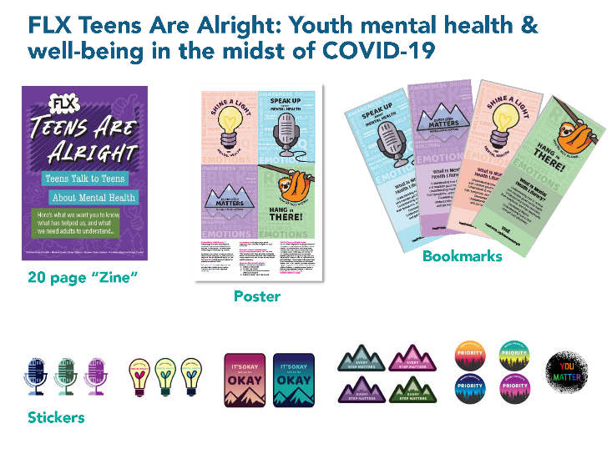
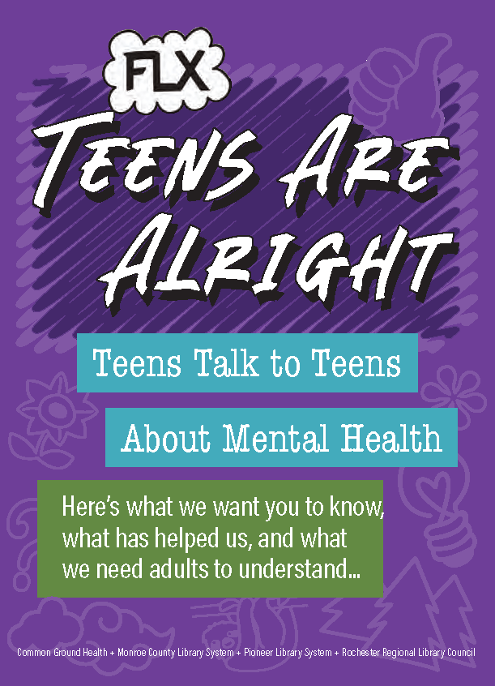

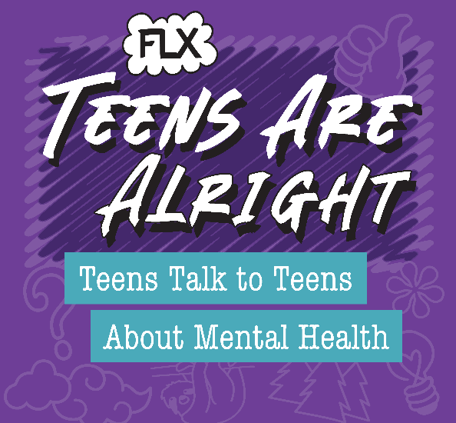

Sample Newsletter Content:
Headline: FLX Teens Are Alright: Youth mental health & well-being in the midst of COVID-19
Sub headline: New teen mental health resources available at local libraries in the Finger Lakes
The FLX Teens Are Alright initiative aims to improve mental health literacy for middle- and high-school aged youth in the Finger Lakes Region of New York. To achieve this, the project brought together a diverse team of 15 local teenagers to create new mental health resources for their peers. Together, youth worked with a team of graphic design professors and students from the Rochester Institute of Technology to design the new materials, which are meant to improve collections and programming in public libraries across Livingston, Monroe, Ontario, Wayne and Wyoming Counties. The initiative was a partnership between Common Ground Health, Monroe County Library System, Pioneer Library System and the Rochester Regional Library Council. A Young Adult Librarian from Monroe County also provided support for the written content of the materials. The Network of the National Library of Medicine provided the funding for this initiative.
To see the materials, stop by your local library and check them out! To learn more, visit healthikids.org/flxteensarealright
Sample Social Posts
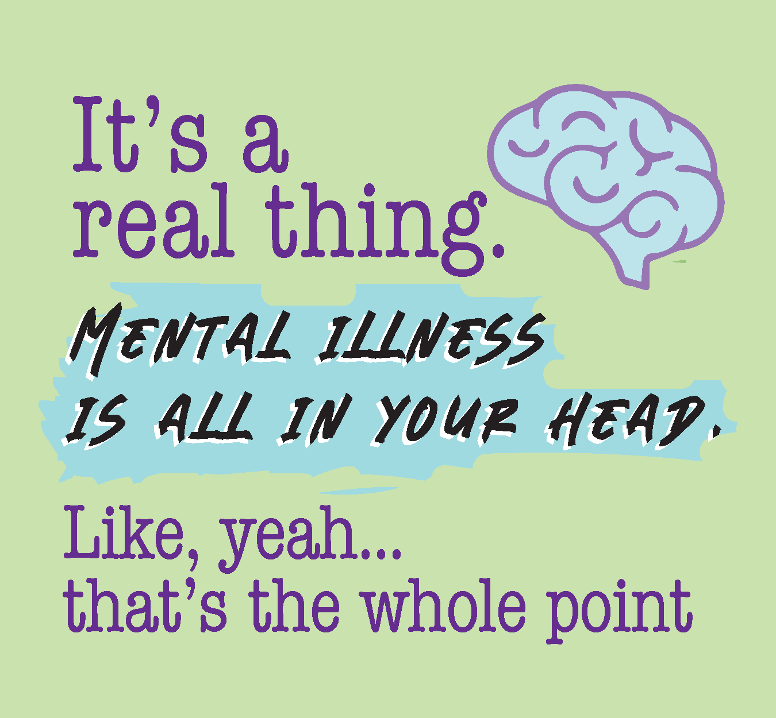
CAPTION
- You’re struggling with anxiety and depression, and people around you act like you can just think your way out of it or ignore it. But that’s not true. It’s a real thing that needs to be treated – and it’s OK to feel crappy about it.
- Stop by your local public library/(insert library name) Public Library to check out the new FLX Teens Are Alright resources, and visit healthikids.org/flxteensarealright to learn more.
#flxteensarealright #mentalhealthawarenessmonth #youthmentalhealth #mentalhealthliteracy

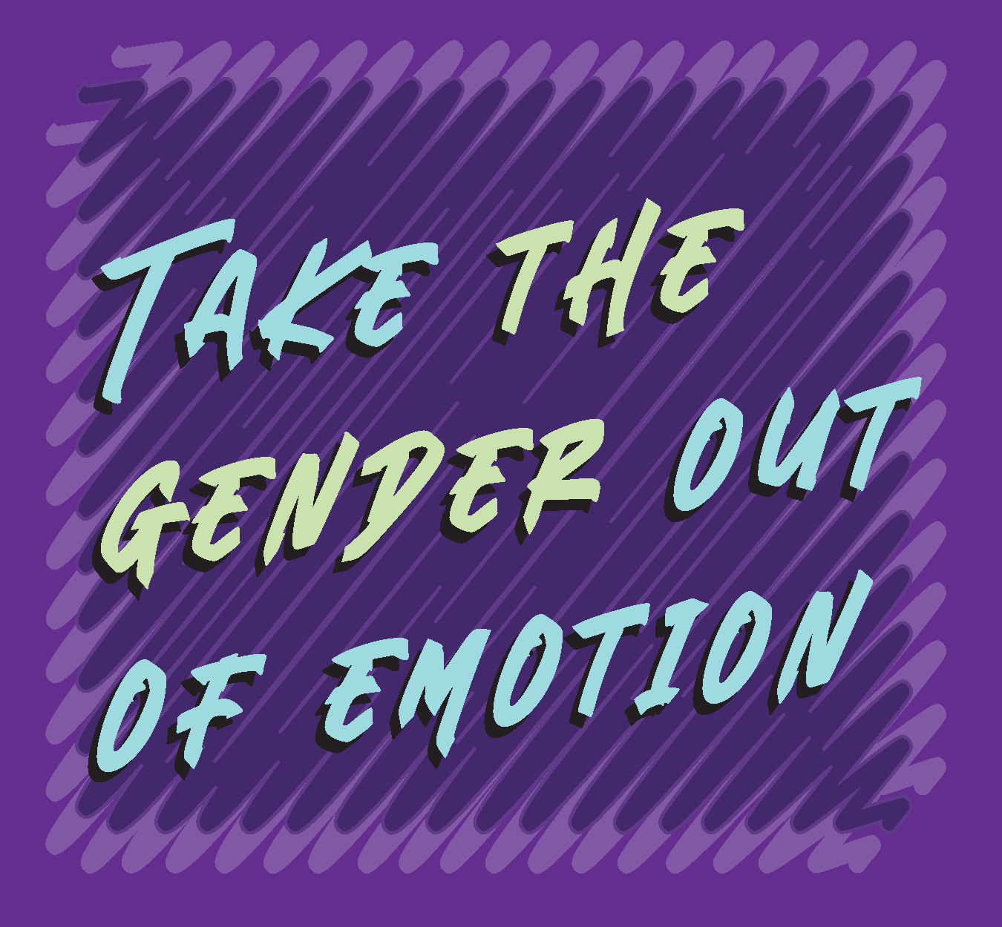
CAPTION
- Anxiety and depression are not a guy thing or a girl thing, a trans thing or a cis thing, a gay thing or a straight thing. All of us are people, and all of us have emotions, whatever they are, own yours.
- Know that showing your emotions isn’t a weakness, and suppressing them does not make you “strong.” You are strong for being your own real you and surviving on this planet.
- Stop by your local public library/(insert library name) Public Library to check out the new FLX Teens Are Alright resources, and visit healthikids.org/flxteensarealright to learn more.
#flxteensarealright #mentalhealthawarenessmonth #youthmentalhealth #mentalhealthliteracy

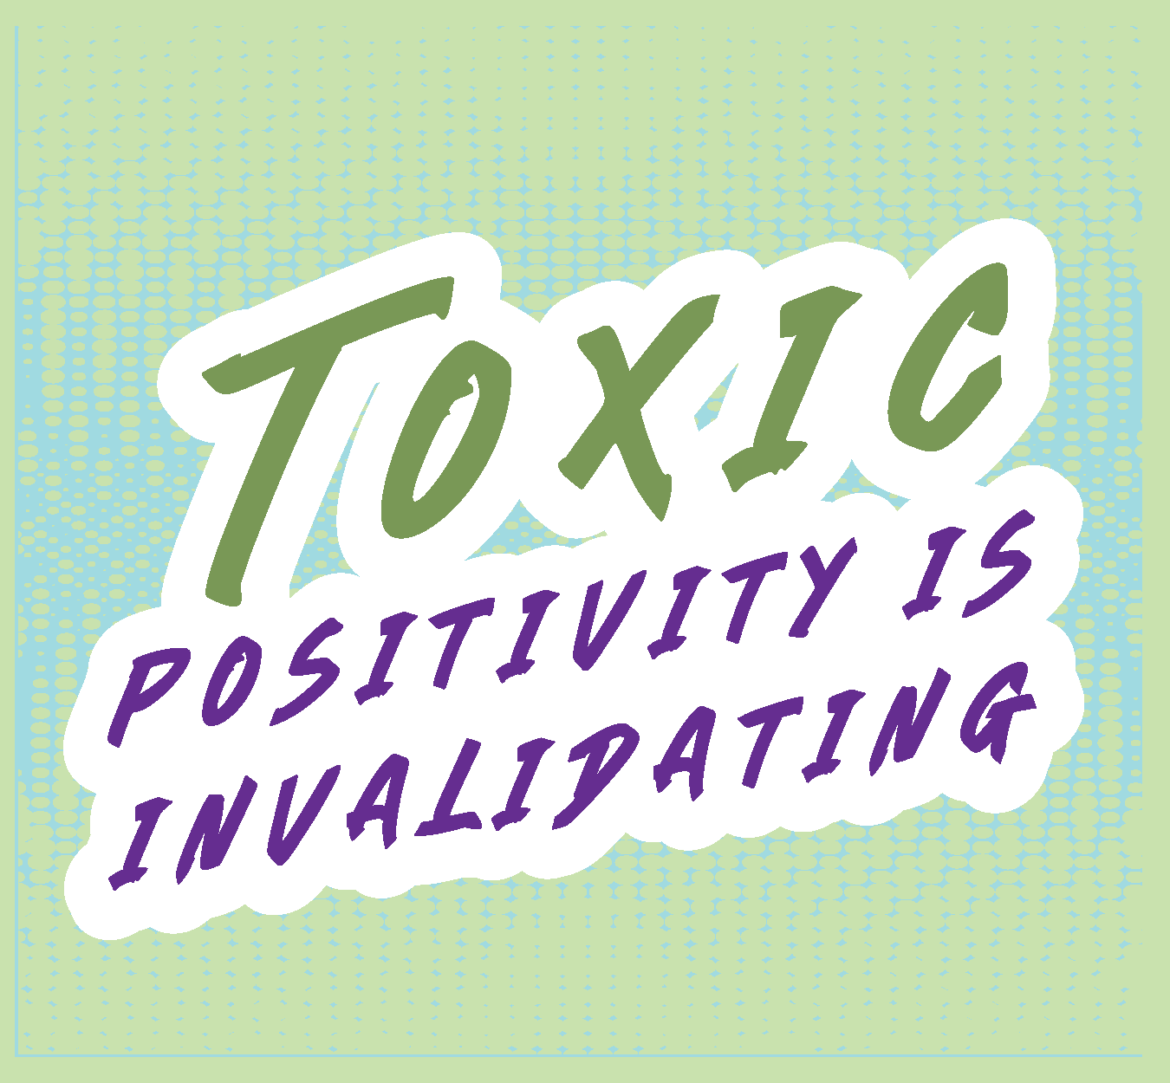
CAPTION
- Life is not always cupcakes and rainbows, so don’t feel like you need to wear a smile every day. Some days suck, and anyone who tells you otherwise is not living in the real world. If you believe your feelings are wrong, you’ll get more stressed.
- Don’t let someone else’s story about their mental state diminish your own. It’s okay to not be okay in whatever form that takes – and then get help from there. You are doing your best day to day.
- Stop by your local public library/(insert library name) Public Library to check out the new FLX Teens Are Alright resources, and visit healthikids.org/flxteensarealright to learn more.
#flxteensarealright #mentalhealthawarenessmonth #youthmentalhealth #mentalhealthliteracy

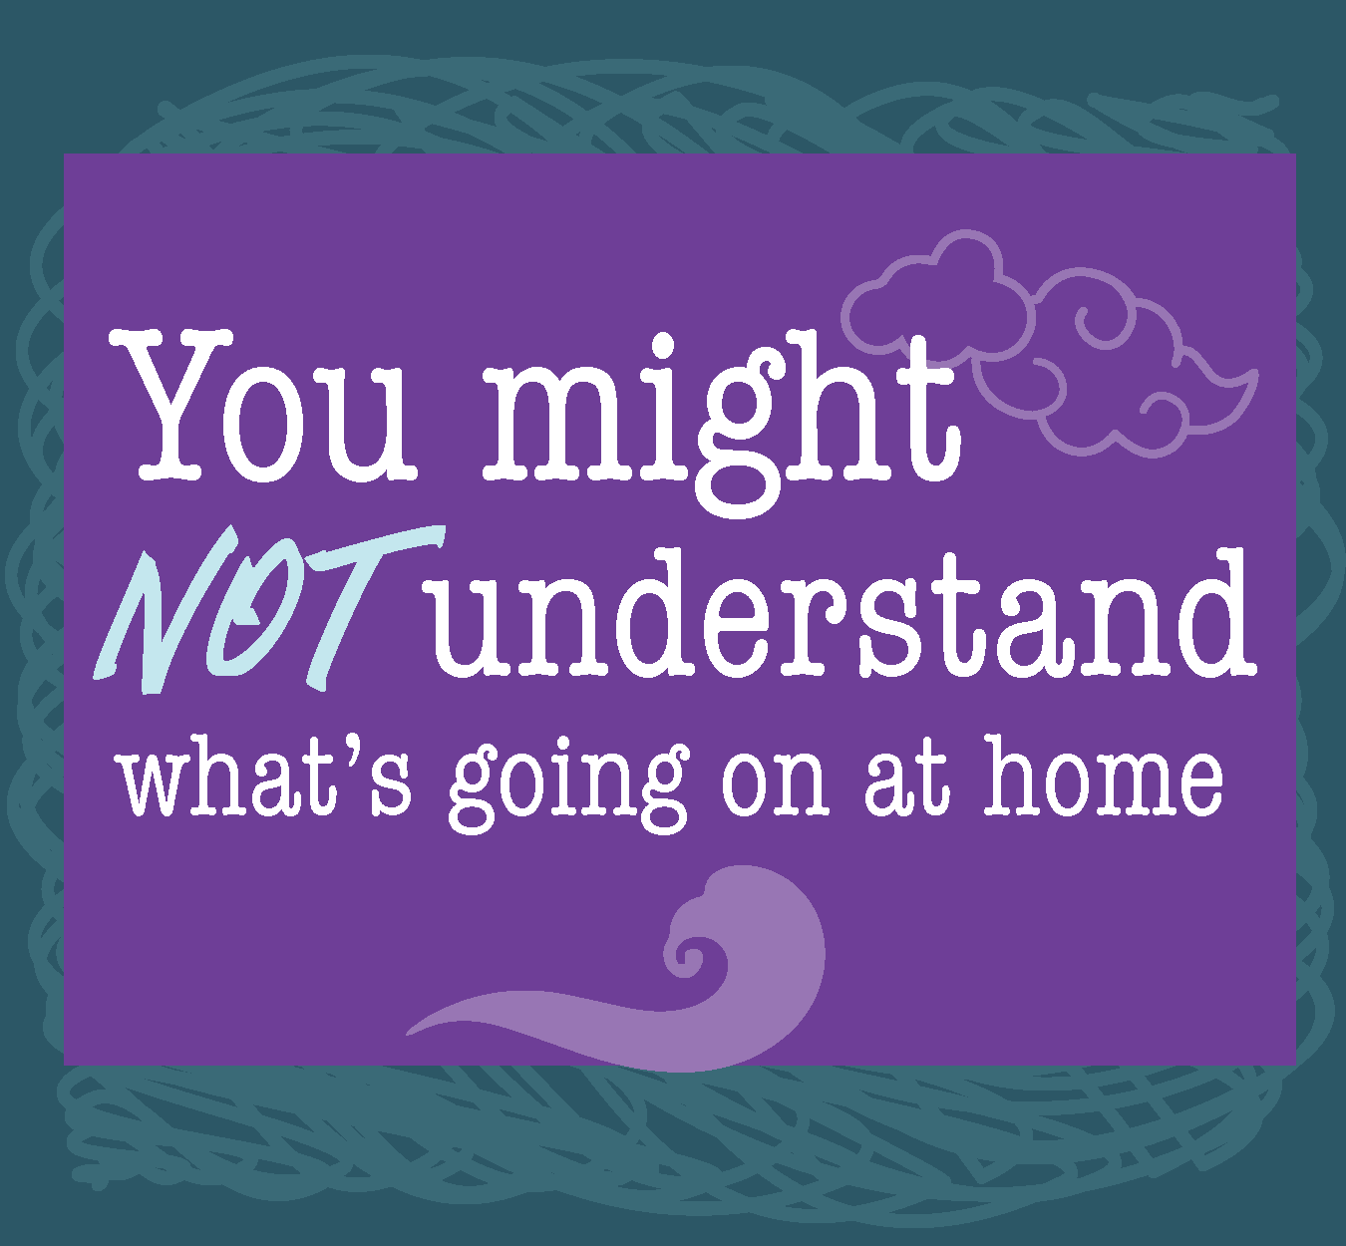
CAPTION
- You get good grades at school, have friends, play a sport or instrument, and seem to be on top of everything. At least, that’s what others see. But in the privacy of your home you can become a whole different person. Know this about yourself and others, and check in with peers to see how we are really doing. Check in with yourself, too.
- If your home life does not feel like a safe space, check in with a trusted adult outside of your home. A trusted adult can be a library employee, school counselor, teacher, a pastor, a friend, relative, coach, or any other adult you trust to have your best interest at heart. Not sure where to start? Ask a peer or a friend to recommend someone.
- Stop by your local public library/(insert library name) Public Library to check out the new FLX Teens Are Alright resources, and visit healthikids.org/flxteensarealright to learn more.
#flxteensarealright #mentalhealthawarenessmonth #youthmentalhealth #mentalhealthliteracy

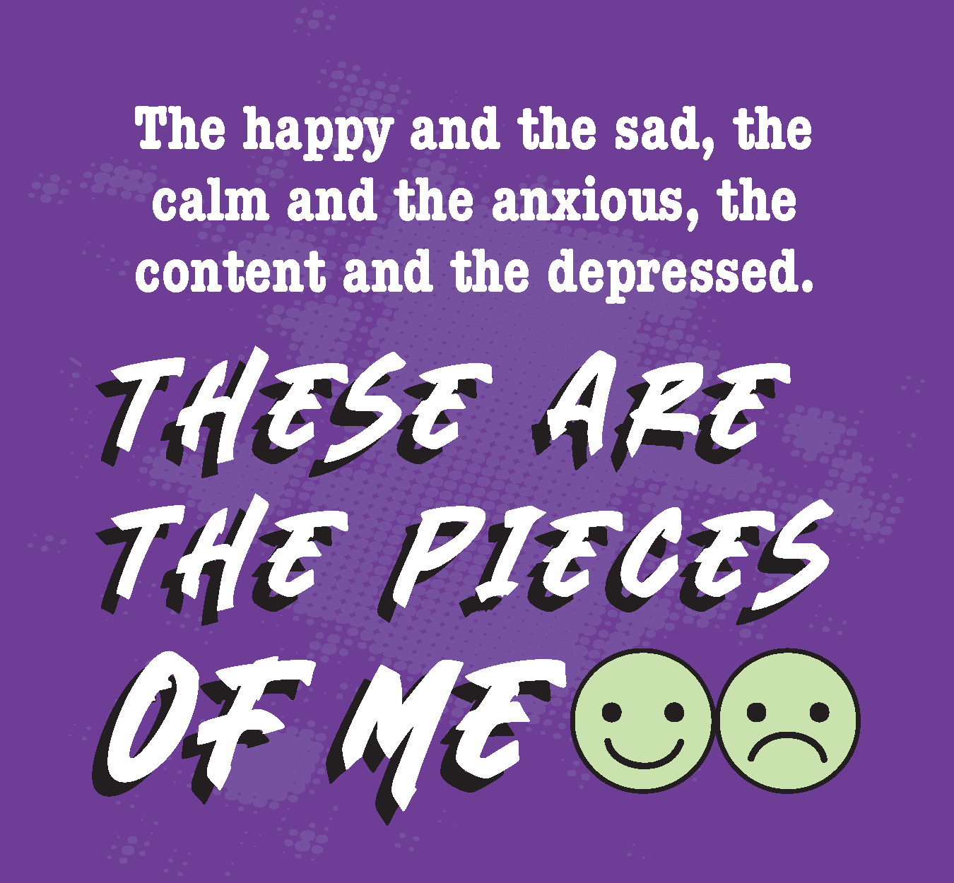
CAPTION
- The happy and the sad, the calm and the anxious, the content and the depressed. These are some emotional pieces that can make up a person -- even in the same hour. Get to know the whole person, and let others know the whole you. Tell people how you feel and what you need. Find a teen who you can share feelings with, and vice versa.
- Stop by your local public library/(insert library name) Public Library to check out the new FLX Teens Are Alright resources, and visit healthikids.org/flxteensarealright to learn more.
#flxteensarealright #mentalhealthawarenessmonth #youthmentalhealth #mentalhealthliteracy

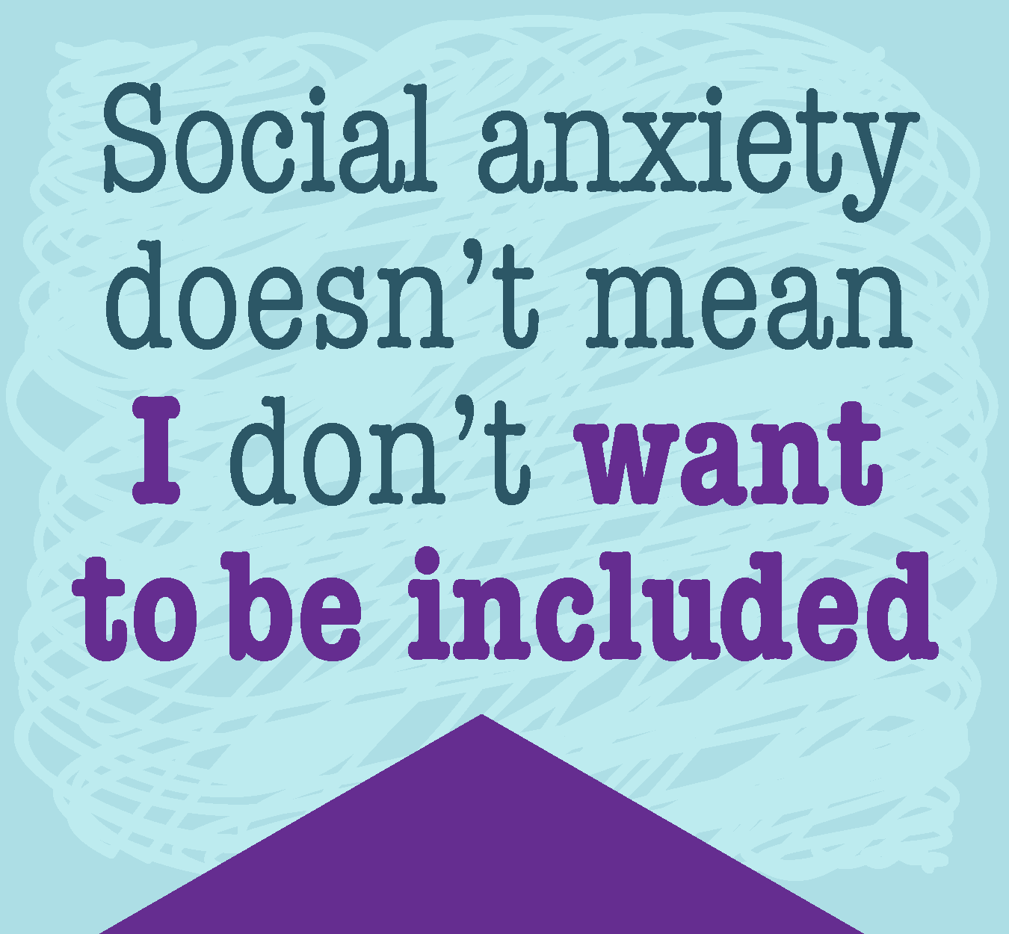
CAPTION
If someone is struggling mentally, don’t call them out on it, blow them off, or make jokes about mental health (not funny). Ask what’s going on or how you can help. And if you’re the one feeling attacked or invisible, confide in a friend or someone who will listen. People often act out of fear of a lack of understanding, but that doesn’t make their actions OK. Visit https://mentalhealthliteracy.org/ to learn more about the basics of teen mental health, and how you can support yourself and your peers.
- If you’re being bullied, go to https://empoweroc.org/bullying/ for help with bullying, and talk to a trusted adult.
- Stop by your local public library/(insert library name) Public Library to check out the new FLX Teens Are Alright resources, and visit healthikids.org/flxteensarealright to learn more.
#flxteensarealright #mentalhealthawarenessmonth #youthmentalhealth #mentalhealthliteracy

CAPTION
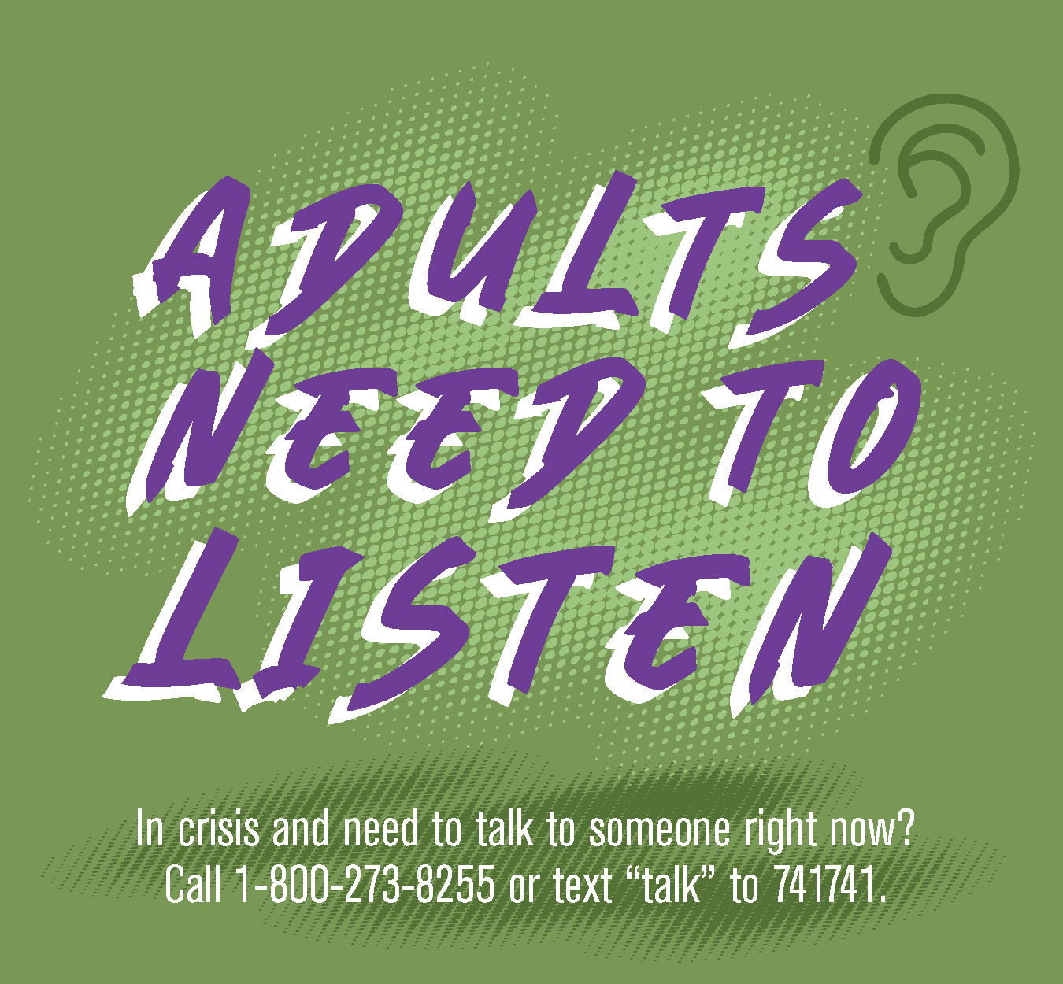
- We go to adults for help, so they need to listen and be open to the truth, even if it’s hard to hear. They may not know how hard we are struggling, but that doesn’t make it less real. Adults need to trust us and take the emotions we are sharing seriously. They need to think before speaking, and then respond with love, trust, and offers of help.
- If the first adult you reach out to doesn’t give you what you need, find another and another and another until you are heard.
- If you are an adult who can be trusted, make it known to the teens in your life. If you are a teen who knows of a trusted adult, share that name with your peers.
- In crisis and need to talk to someone right now? Call 1-800-273-8255 or text “talk” to 741741.
- Stop by your local public library/(insert library name) Public Library to check out the new FLX Teens Are Alright resources, and visit healthikids.org/flxteensarealright to learn more.
#flxteensarealright #mentalhealthawarenessmonth #youthmentalhealth #mentalhealthliteracy

CAPTION
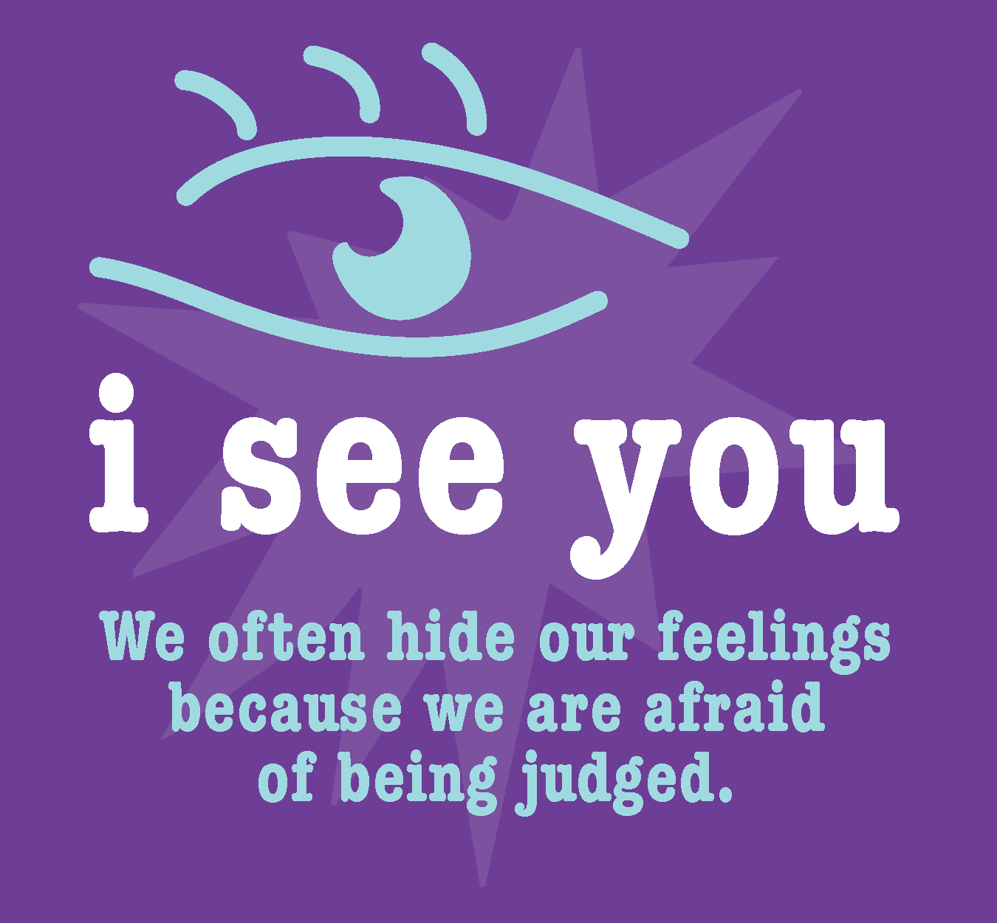
- We often hide our feelings because we are afraid of being judged. Yet if we all shared, we would see that we are not alone. Everyone has their own struggles with family, friends, mental and/or physical health, school, and more. Each of our experiences, feelings, and opinions are valid. There is always more to a person than what they decide to show to the world. Try to reach that person – and be that person.
- Stop by your local public library/(insert library name) Public Library to check out the new FLX Teens Are Alright resources, and visit healthikids.org/flxteensarealright to learn more.
#flxteensarealright #mentalhealthawarenessmonth #youthmentalhealth #mentalhealthliteracy

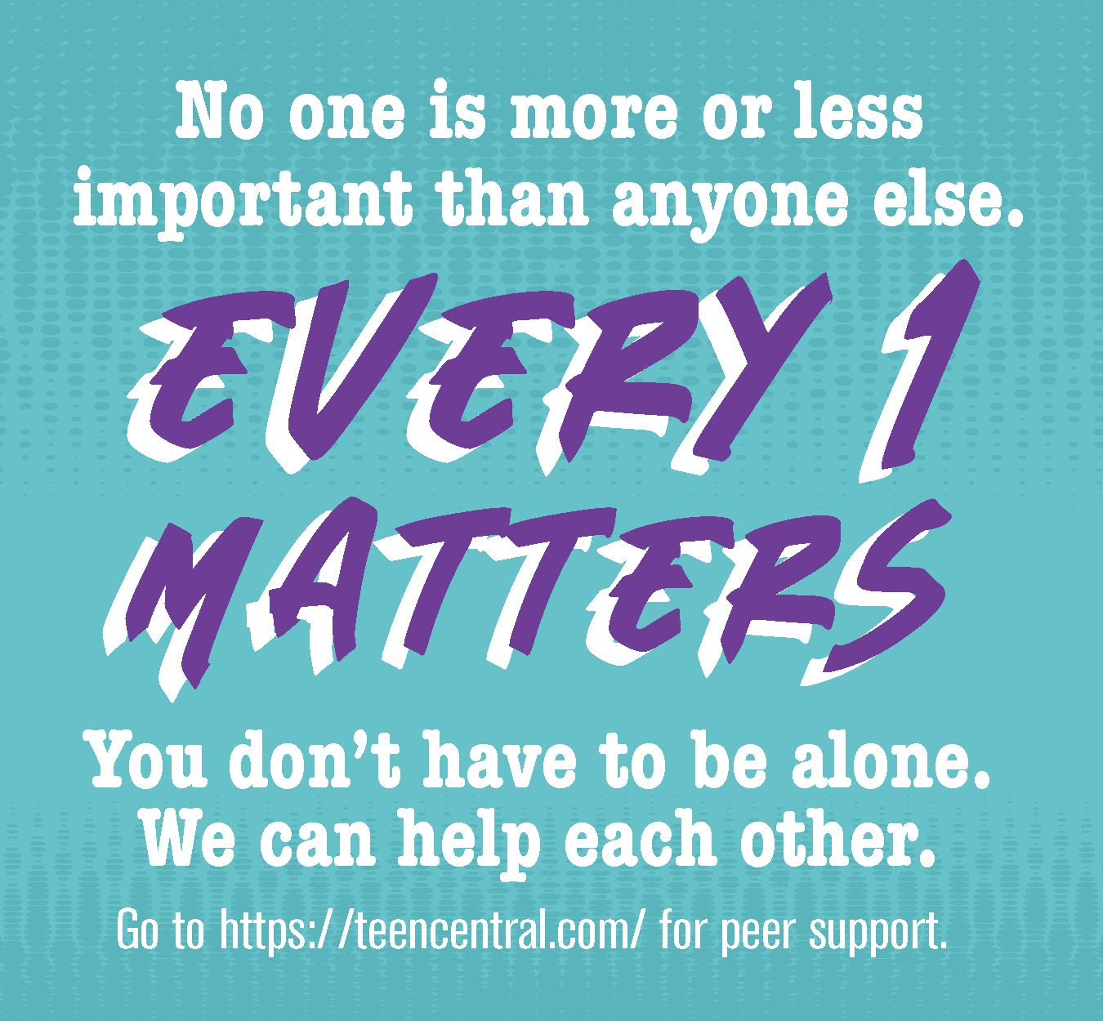
CAPTION
- No one is more or less important than anyone else. We might be from different schools, cities, counties, states, but we are all still teens and can empathize with one another. Find someone to support you and care for you. You don’t have to be alone. We can help each other. Go to https://teencentral.com/ for peer support.
- Stop by your local public library/(insert library name) Public Library to check out the new FLX Teens Are Alright resources, and visit healthikids.org/flxteensarealright to learn more.
#flxteensarealright #mentalhealthawarenessmonth #youthmentalhealth #mentalhealthliteracy

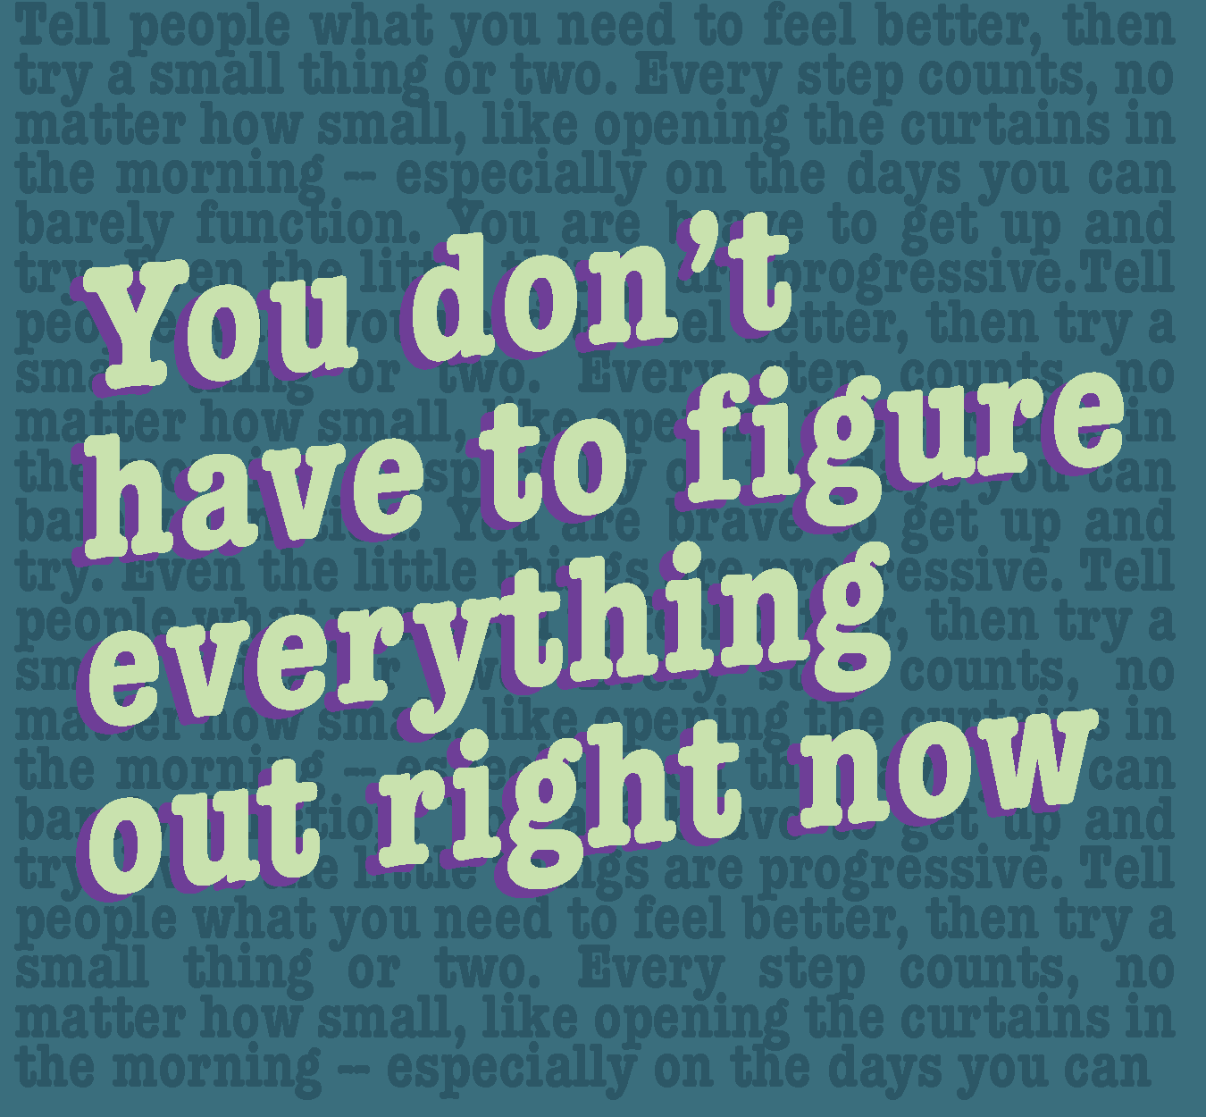
CAPTION
- Tell people what you need to feel better, then try a small thing or two. Every step counts, no matter how small, like opening the curtains in the morning -- especially on the days you can barely function. You are brave to get up and try. Even the little things are progressive.
- Share stories with others about your efforts, what worked and what didn’t, and what you’ll try next time. Go to https://teencentral.com/tools/ for some small ideas you can try to help with your mental health.
- Stop by your local public library/(insert library name) Public Library to check out the new FLX Teens Are Alright resources, and visit healthikids.org/flxteensarealright to learn more.
#flxteensarealright #mentalhealthawarenessmonth #youthmentalhealth #mentalhealthliteracy

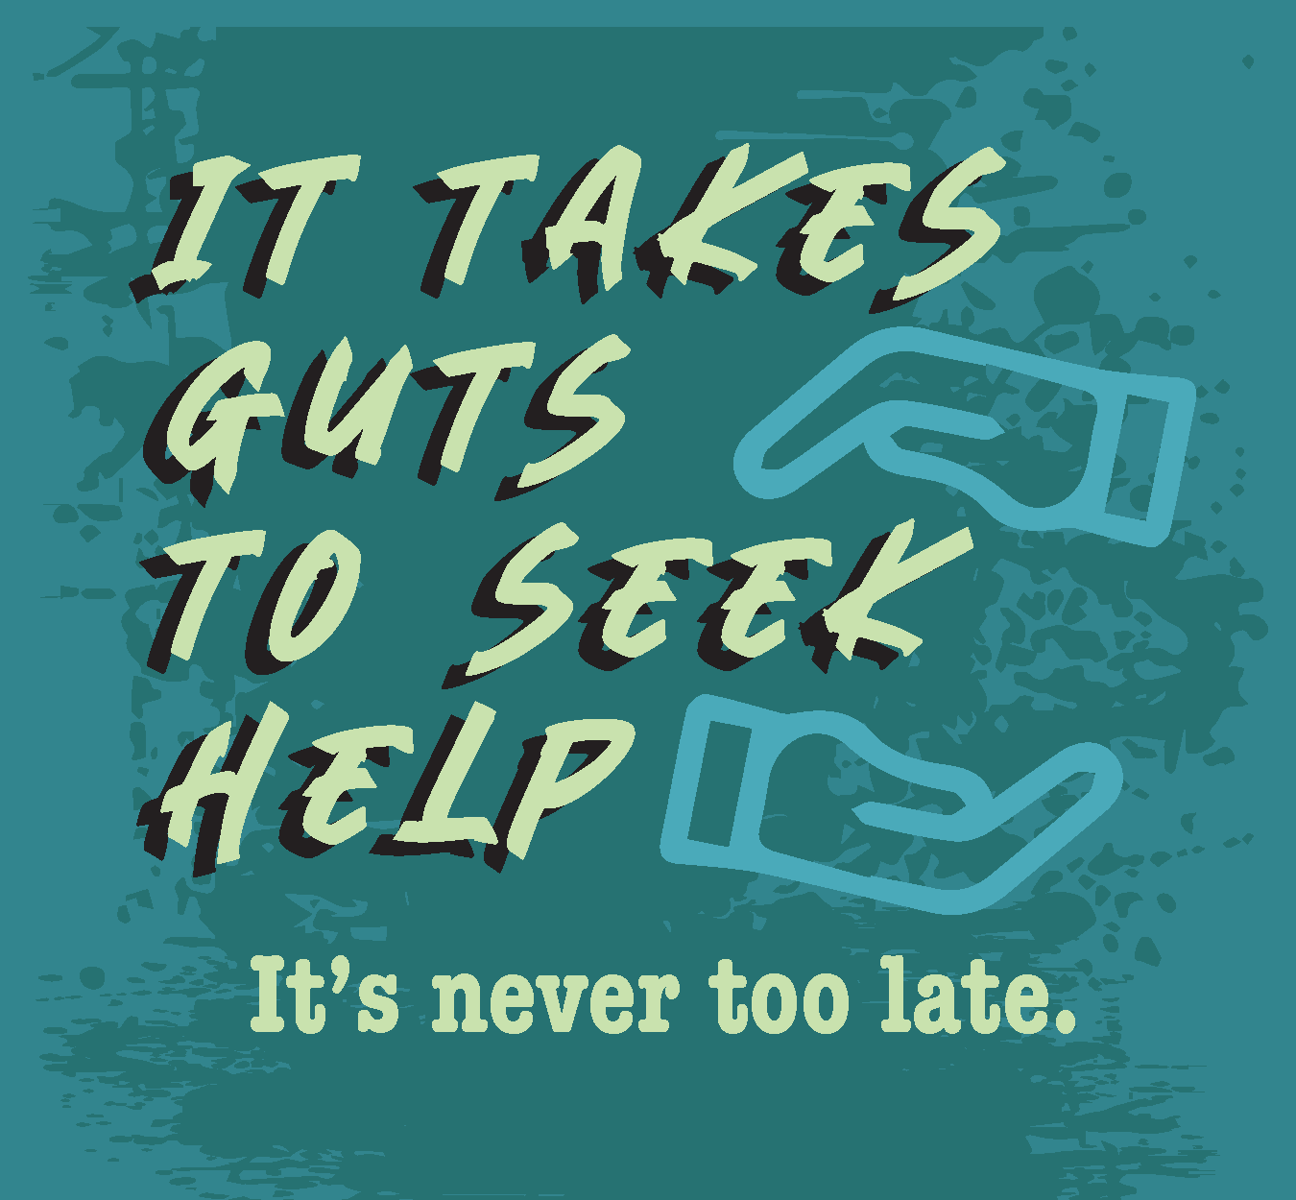
CAPTION
- Tell an adult you need a medical professional to get better. Know that you might have a dud therapist or doctor before you land on the right one. Even your parents might not be the right adults to talk to about your anxiety and depression. It’s OK to be selfish for your mental health and find the person who will help you most.
- It can take years for some of us to speak up and ask for help. But it’s never too late. Start with a peer, and with their support, go to a trusted adult and begin your path to feeling better. If you are ignored or someone walks away, try again with the next person. You are worth the effort!
- Stop by your local public library/(insert library name) Public Library to check out the new FLX Teens Are Alright resources, and visit healthikids.org/flxteensarealright to learn more.
#flxteensarealright #mentalhealthawarenessmonth #youthmentalhealth #mentalhealthliteracy

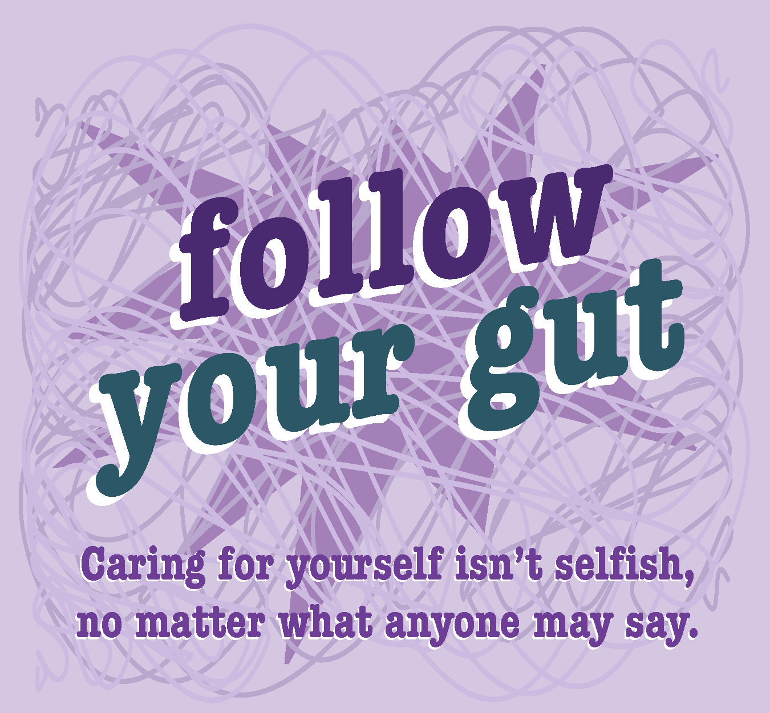
CAPTION
- Adults in your life want to do what is best for you, but sometimes they don’t know how. Speak up about your needs. Everyone is unique and you should never stop seeking contentment. Caring for yourself isn’t selfish, no matter what anyone may say.
- Stop by your local public library/(insert library name) Public Library to check out the new FLX Teens Are Alright resources, and visit healthikids.org/flxteensarealright to learn more.
#flxteensarealright #mentalhealthawarenessmonth #youthmentalhealth #mentalhealthliteracy

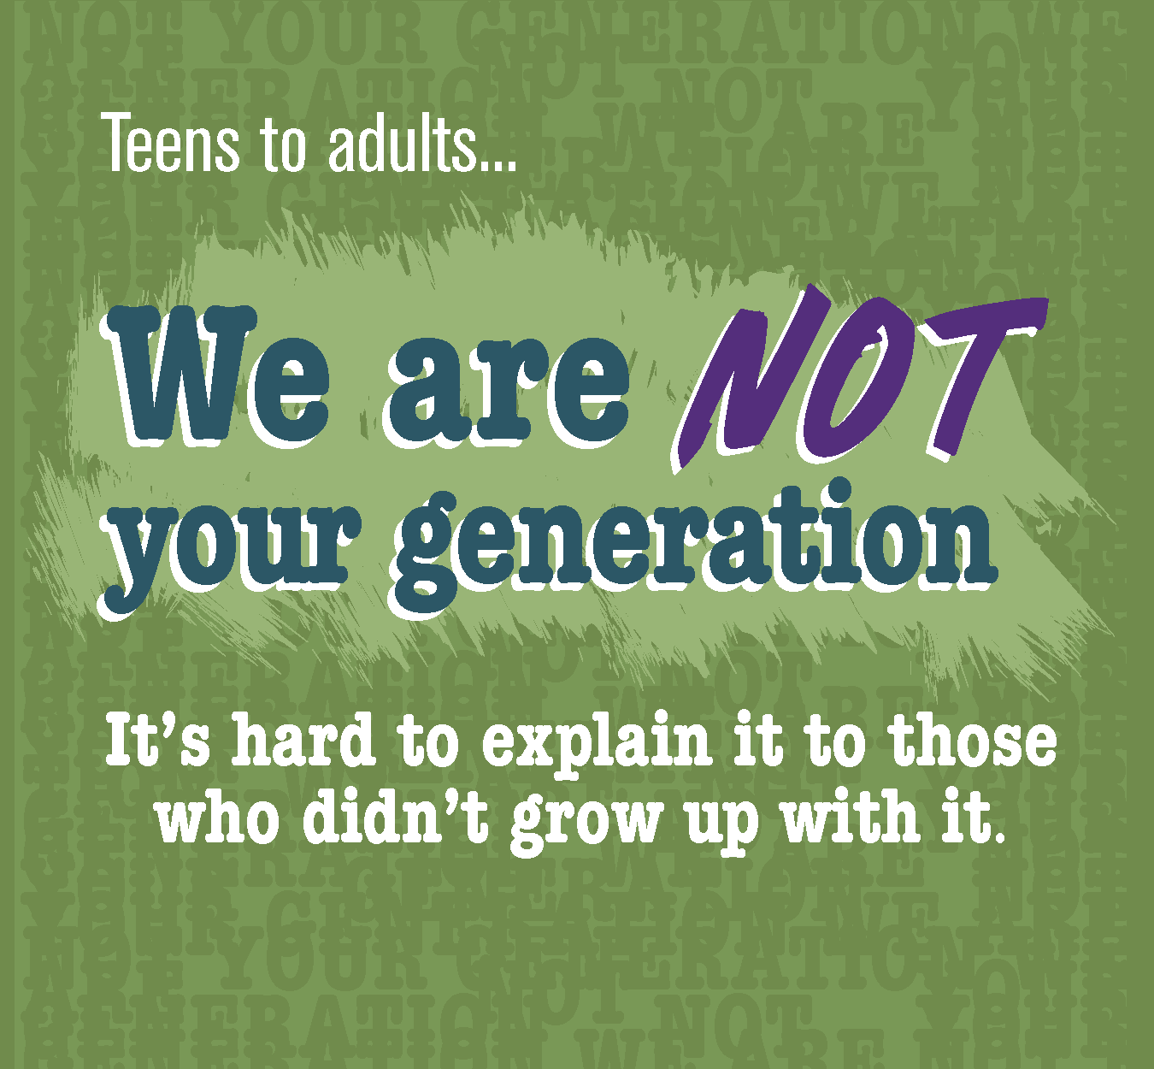
CAPTION
- Parents, teachers, guidance counselors, and other adults will tell us that “back in their day” they did XYZ. But that’s irrelevant today because of the internet, social media, smart phones, and other technology. And it’s hard to explain it to those who didn’t grow up with it. Things are changing so fast we can barely keep up, let alone our parents. Go to https://engage.youth.gov/resources/tip-sheet-social-media-use-and-mental-health to learn more about healthy social media use.
- Stop by your local public library/(insert library name) Public Library to check out the new FLX Teens Are Alright resources, and visit healthikids.org/flxteensarealright to learn more.
#flxteensarealright #mentalhealthawarenessmonth #youthmentalhealth #mentalhealthliteracy

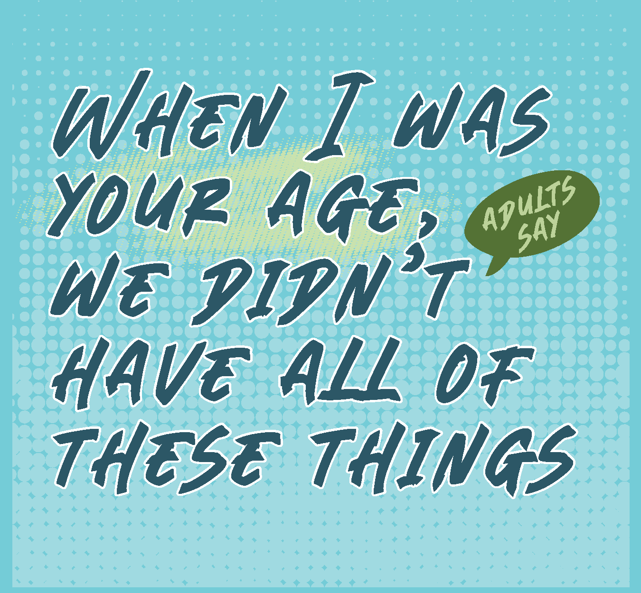
CAPTION
- Don’t let an adult tell you that LGBTQIA+ people did not exist “when they were your age.” They are wrong. People of all genders and orientations have always existed. We can just learn about the continuum faster now because of the internet. But just because we have the information, it doesn’t mean we have all the answers. The Trevor Project has trained counselors for young LGBTIQIA+ people who are in crisis, feeling suicidal, or in need of a safe and judgment-free place to talk, chat or text. Visit thetrevorproject.org to learn more.
- Stop by your local public library/(insert library name) Public Library to check out the new FLX Teens Are Alright resources, and visit healthikids.org/flxteensarealright to learn more.
#flxteensarealright #mentalhealthawarenessmonth #youthmentalhealth #mentalhealthliteracy

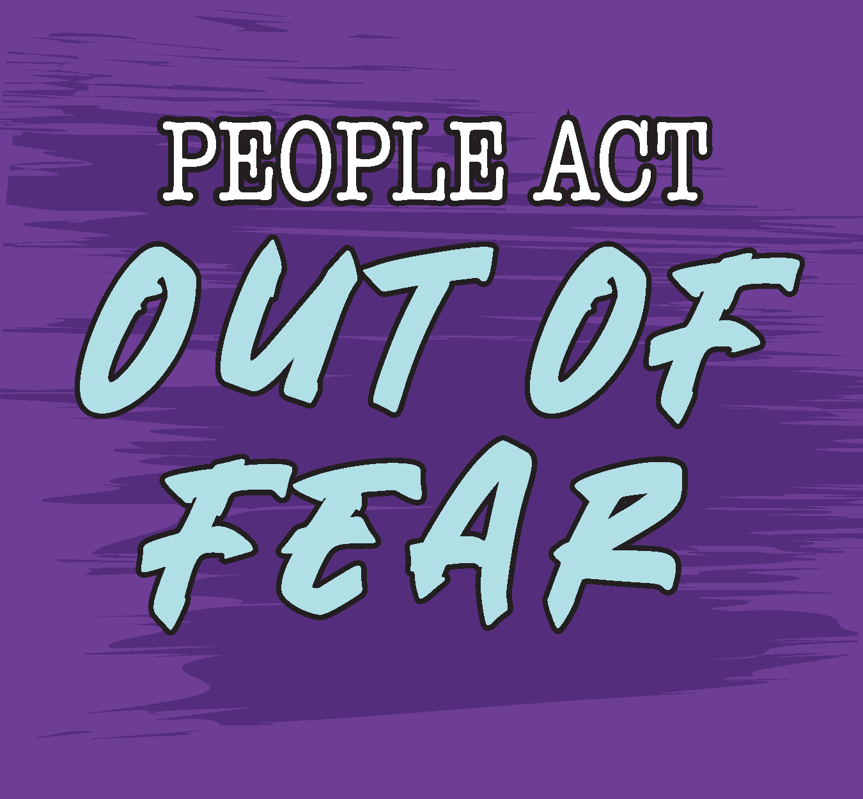
CAPTION
- Parents, teachers, and adults in general will tell us we are lazy, whiny, emotional teens instead of trying to get to the root of our emotions. A fight is sometimes easier than facing the truth about our mental health.
- To help understand us, classes for teachers and parents should be offered on the topic of Teen Mental Health. Visit https://mentalhealthliteracy.org/product/teening-your-parent/ to learn more about how adults can support teens and their mental health.
- Stop by your local public library/(insert library name) Public Library to check out the new FLX Teens Are Alright resources, and visit healthikids.org/flxteensarealright to learn more.
#flxteensarealright #mentalhealthawarenessmonth #youthmentalhealth #mentalhealthliteracy

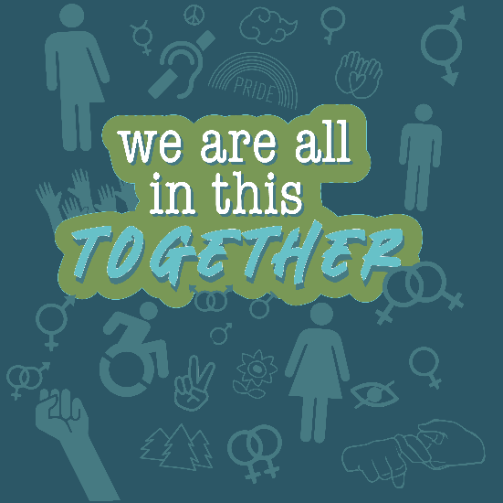
CAPTION
“It is very hard to be there for others all the time when no one is there for you at the end of the day.”
- Be there for yourself. Be there for your peers. Find the adults and teens who will be there for you.
- Stop by your local public library/(insert library name) Public Library to check out the new FLX Teens Are Alright resources, and visit healthikids.org/flxteensarealright to learn more.
#flxteensarealright #mentalhealthawarenessmonth #youthmentalhealth #mentalhealthliteracy

Additional Social Media Images & Captions
SAMPLE CAPTION
May is Mental Health Awareness Month. Stop by your local public library (or insert library name) to check out the new FLX Teens Are Alright mental health resources. Created by 15 local teenagers –they tell you everything you need to know right now about youth mental health.
SAMPLE CAPTION
What is youth mental health literacy?? Understanding how to foster and maintain good mental health. Understanding mental disorders and their treatments. Decreasing Stigma. Understanding how to seek help effectively. Libraries are a great place to improve your mental health literacy!
SAMPLE CAPTION
Youth mental health literacy is important! Whether you struggle with mental health challenges or not, it’s important to know how you can take care of yourself and support your peers. Visit your local library to check out the new FLX Teens Are Alright mental health resources, and learn more from your peers about mental health. While you’re there, talk to your librarian about where and how to find more information.
SAMPLE CAPTION
Becoming a mental health literate teen –what your peers want you to know right now:
1. Emotions are normal & valid
2. You matter & are not alone.
3. Our generation is facing unique challenges that adults may not understand.
4. Speak up for yourself & ask for what you need.
SAMPLE CAPTION
Make connections –connectivity with peers, friends and adults is like a life jacket, it keeps you afloat. Connections with others supports teen mental health. Ask your librarian about support groups, clubs or organizations in your community you might be able to get involved with.
SAMPLE CAPTION
Know you’re not alone. Visit healthikids.org/flxteensarealright and check out our new “zine” called “FLX Teens Are Alright: Teens talk to teens about mental health”. Hear from teens in the Finger Lakes Region about what you need to know, what can help, and what we need adults to understand.
HASHTAGS
#flxteensarealright #mentalhealthawarenessmonth #youthmentalhealth #mentalhealthliteracy

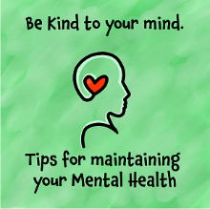
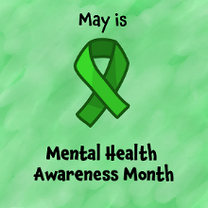

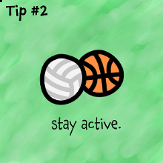
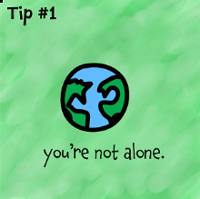

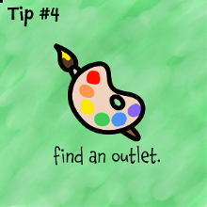
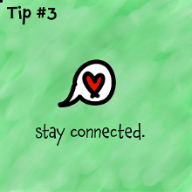

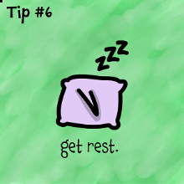
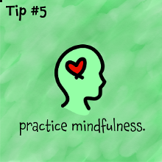

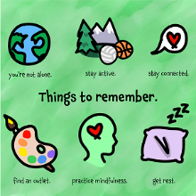
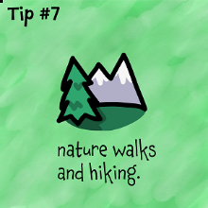

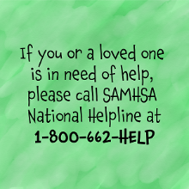

FLX Teens Are Alright: Youth mental health & well-being in the midst of COVID-19
Project Background
The FLX Teens Are Alright initiative aims to improve mental health literacy for middle- and high-school aged youth in the Finger Lakes Region of New York. To achieve this, the project brought together a diverse team of 15 local teenagers to create new mental health resources for their peers. Together, youth worked with a team of graphic design professors and students from the Rochester Institute of Technology to design the new materials, which are meant to improve collections and programming in local libraries across Livingston, Monroe, Ontario, Wayne and Wyoming Counties. The initiative was a partnership between Common Ground Health, Monroe County Library System, Pioneer Library System and the Rochester Regional Library Council. A Young Adult Librarian from Monroe County also provided support for the written content of the materials. The Network of the National Library of Medicine provided the funding for this initiative. To see the materials, stop by your local library and check them out! To learn more, visit healthikids.org/flxteensarealright
New FLX Teens Are Alright Resources
The new FLX Teens Are Alright collection includes a 20 page “zine”, a poster, bookmarks (4 different versions), and stickers (over 10 different kinds).
How to access the materials
Printed copies of the zine, poster, bookmarks and stickers are being distributed to the 74 public libraries across Livingston, Monroe, Ontario, Wayne and Wyoming counties. Please note, due to limited supply, the zines are meant to be reference copies and remain in the library. Bookmarks and stickers should be distributed to any youth who would like them. Electronic versions of all of the materials are also available for viewing and download at healthikids.org/flxteensarealright. If interested in printing additional copies of any of the materials, we would be happy to share the print files with you. For additional printing inquiries, please contact Hannah Shippee at Common Ground Health, at Hannah.shippee@commongroundhealth.org. News of the new materials and information on how to access them will be shared widely with teen serving organizations across the region.
Suggestions for incorporating the new materials in to library programming
- Check out the social media toolkit at healthikids.org/flxteensarealright and participate in our social media campaign for Mental Health Awareness Month in May (or any time of the year!).
- Place the printed materials in the teen and/or young adult sections.
- Place posters in areas that teens frequent (e.g. computer lab), to serve as positive reminders.
- Consider creating a peer support group for teens interested in mental health.
- Consider having speakers come in to talk about teen mental health topics.
- Create space for adults to learn more about supporting the mental health of teens in their lives.
- Ask teens what they would like to see for youth mental health programming at the library!
Questions?
Reach out to Hannah Shippee at Common Ground Health with any questions: Hannah.shippee@commongroundhealth.org

