Sunday | Monday | Tuesday | Wednesday |  | Thursday | Friday | Saturday
 |  |  |  | 1  Yom Kippur Begins  cccZ | 2 | 3 | 4
5 | 6  Sukkot Begins | 7 |  | 8 | 9 | 10 | 11
12 | 13  Thanksgiving Day (Canada)  Indigenous Peoples’ Day  Columbus Day (U.S.) | 14  Simchat Torah Begins |  | 15 | 16 | 17 | 18
19 | 20 | 21 |  | 22 | 23 | 24 | 25
26 | 27 | 28 |  | 29 | 30 | 31  Halloween

Activity Calendar  AM Program  . |  |  | 10:00 Book Club with Liz  10:00 Card Games with G | 9:30 Ladder Ball  10:00 Drumming Circle!  11:00 Bingo | 10:00 Book Club with Liz  11:00 Bingo | 10:00 Independent Activities  11:00 Music  1:00 Bingo
Lunch served at 11:45am  Snack served at 2:00pm  Dinner served at 4:45  | 9:30 Balloon Volley  10:00 Art & Soul  10:30 Cards & Dominoes | 9:30 Ladderball  10:00 Halloween Craft with Liz!  11:00 Bingo with G! | Flu & COVID Vaccine Clinic  10:00 Special Event: Drumming Circle! | 9:30 Ladder Ball  10:00 Singo with Garrett  11:00 Bingo | 10:00 Happy Hour Concert with Kevin!  11:00 Bingo | 10:00 Independent Activities  11:00 Music  1:00 Bingo
A variety of independent activities are always available – ask staff! | 9:30 Balloon Volley  10:00 Art & Soul  10:30 Cards & Dominoes | 10:00 Registrant Council  11:00 Bingo with G! | EARLY DAY  With Brunch!  10:00 Halloween Crafts with Liz!  11:00 Balloon Volley | 10:00 Special Event: Hawk Creek!  11:00 Bird  Collage | 10:00 Craft: Making Spiders!  11:00 Bingo  1:00 OUTING:  Pumpkin Farm! | 10:00 Independent Activities  11:00 Music  1:00 Bingo
Community outings: Family Dollar trips are offered Tuesdays and Wednesdays!  Sign up in the Day Room! | 9:30 Balloon Volley  10:00 Art & Soul  10:30 Cards & Dominoes | 9:30 Calendar Planning  10:00 Singo with Garrett  11:00 Bingo with G! | 10:00 Family Feud!  11:00 Halloween Stories | 9:30 Ladder Ball  10:00 Chair Yoga with Shaq!! | 1:00 OUTING: Buffalo History Museum in Delaware Park  11:00 Bingo | 10:00 Independent Activities  11:00 Music  1:00 Bingo
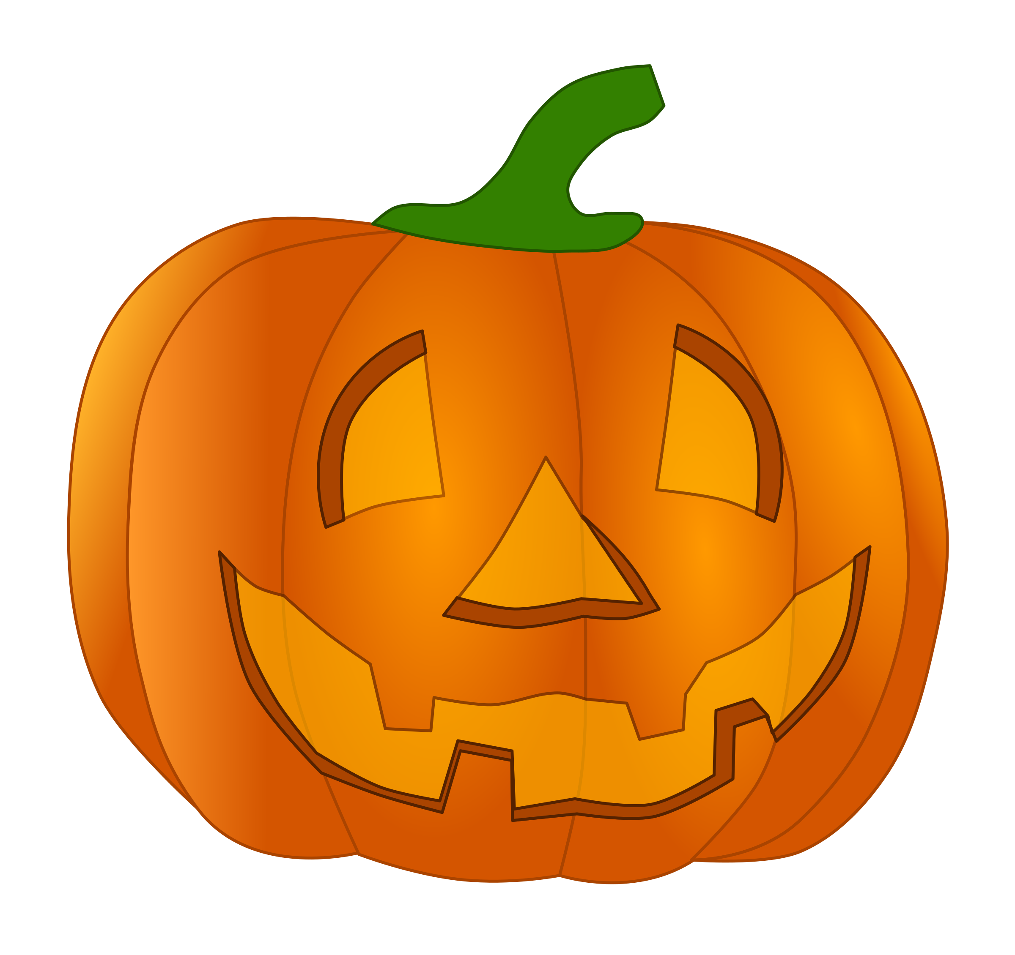 | 9:30 Balloon Volley  10:00 Art & Soul  10:30 Cards & Dominoes | 10:00 Card Bingo & Tiny Town with Mara  11:00 Bingo with G! | 9:30 Who Am I? What Am I?  10:00 Movie & Pajama Party! | 10:00 Pumpkin Carving and Contest!  11:00 Bingo | 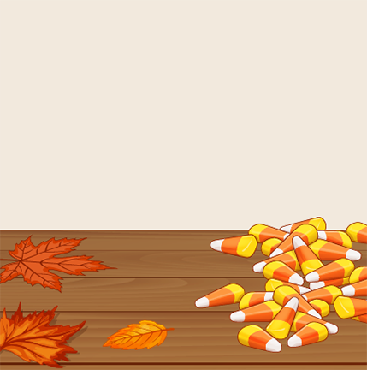  10:00 Halloween  Party!  11:00 Bingo | Happy Halloween!
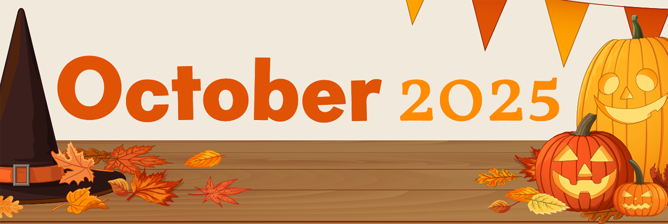
Schofield Adult Day Health Care Program ~ 190 Fulton Street, Buffalo NY 14201 ~ 716-849-8720

