Sunday | Monday | Tuesday | Wednesday |  | Thursday | Friday | Saturday
 |  |  |  | 1  Yom Kippur Begins  cccZ | 2 | 3 | 4
5 | 6  Sukkot Begins | 7 |  | 8 | 9 | 10 | 11
12 | 13  Thanksgiving Day (Canada)  Indigenous Peoples’ Day  Columbus Day (U.S.) | 14  Simchat Torah Begins |  | 15 | 16 | 17 | 18
19 | 20 | 21 |  | 22 | 23 | 24 | 25
26 | 27 | 28 |  | 29 | 30 | 31  Halloween

Activity Calendar  PM Program |  |  | 2:00 Family Dollar with Liz!  3:00 Card Games with G!  4:00 Bingo with Travis | 1:30 Balloon Volley  2:00 Card Bingo & Tiny Town Dominoes | 2:00 Book Club with Liz  3:00 Nail Salon  4:00 Bingo with Travis | 10:00 Independent Activities  11:00 Music  1:00 Bingo
Lunch served at 11:45am  Snack served at 2:00pm  Dinner served at 4:45 | 1:30 Balloon Volley  2:00 Art & Soul  4:00 Bingo with Travis | 1:30 Ladderball  2:00 Halloween Craft with Liz!  3:30 Trivia! | Flu & COVID Vaccine Clinic  3:00 Card Bingo with Mara  4:00 Bingo | 1:30 Balloon Volley  2:00 Special Event  Drumming Circle! | 2:00 Happy Hour Concert with Kevin!  4:00 Bingo with Travis | 10:00 Independent Activities  11:00 Music  1:00 Bingo
Lunch served at 11:45am  Snack served at 2:00pm  Dinner served at 4:45 | 1:30 Balloon Volley  2:00 Art & Soul  4:00 Bingo with Travis | 2:00 Registrant Council  3:00 Singo with Garrett | EARLY DAY  With Brunch!  1:30 Balloon Volley  2:00 Halloween Crafts with Liz! | 2:00 Special Event: Hawk Creek!  3:00 Trivia Challenge! | 1:00 OUTING:  Pumpkin Farm!  3:00 Nail Salon  4:00 Bingo with Travis | 10:00 Independent Activities  11:00 Music  1:00 Bingo 
Community outings: Family Dollar trips are offered Tuesdays and Wednesdays!  Sign up in the Day Room! | 1:30 Balloon Volley  2:00 Art & Soul  4:00 Bingo with Travis | 1:30 Calendar Planning  2:00 Singo with Garrett  3:00 Card Games with G! | 2:00 Family Dollar with Liz!  3:00 Family Feud!  4:00 Bingo | 1:30 Stretch  & Smile  2:00 Halloween Stories  3:00 Who Am I? What Am I? | 1:00 OUTING: Buffalo History Museum in Delaware Park  4:00 Bingo | 10:00 Independent Activities  11:00 Music  1:00 Bingo
 | 9:30 Balloon Volley  2:00 Art & Soul  4:00 Bingo with Travis | 2:00 Chair Yoga with Shaq!  3:00 Card Games with G! | 2:00 Movie & Pajama Party!  4:00 Bingo with Travis | 2:00 Pumpkin Carving and Contest! | 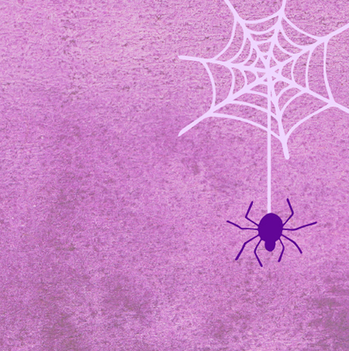  2:00 Halloween Party!!!  4:00 Bingo with Travis | Happy Halloween
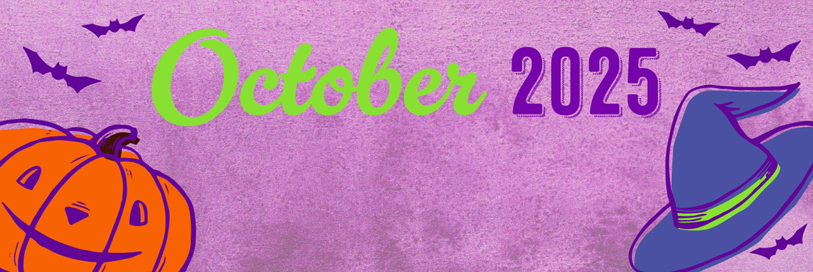
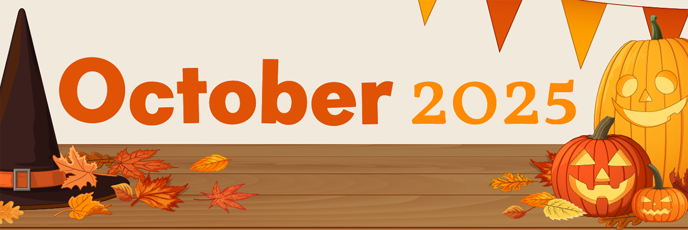
Schofield Adult Day Health Care Program ~ 190 Fulton Street, Buffalo NY 14201 ~ 716-849-8720

