Low Blood Sugar (Not enough sugar in your blood)
Check your sugar Drink fruit juice or chew hard candies
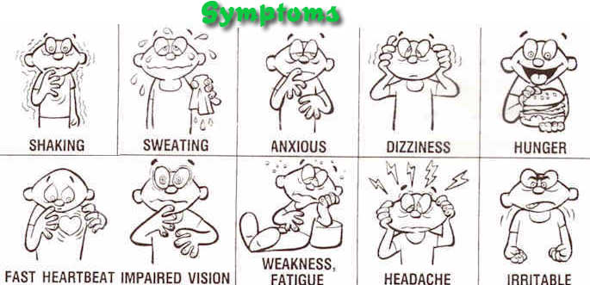

High Blood Sugar
Check your sugar Call your doctor if you are worried
